

**Faculty of engineering - Shoubra**

**Benha University**

**Research Article / Research Project / Literature Review**

in fulfillment of the requirements of

|  |  |
| --- | --- |
| **Department** | **Electrical Engineering** |
| **Division** | **Communication and Electronics** |
| **Academic Year** | **1st year** |
| **Course name** | **Computer Application 1** |
| **Course code** | **ECE124C** |

**Title: -**

**"Research Project: Web Site using HTML, CSS, and JS"**

By:

|  |  |  |  |
| --- | --- | --- | --- |
|  | Name | Edu mail | B.N |
| 1 | مونيكا رأفت يسف كمال غطاس | Monica180879@feng.bu.edu.eg | 141096 |

**Approved by:**

|  |  |
| --- | --- |
| Examiners committee | Signature |
|  |  |
|  |  |
|  |  |
|  |  |
|  |  |

**Topic:**  Sport.

**Application Brief:**

Sport is very important topic and has many details which I can use to show my knowledge in HTML , CSS and Java Script.

By using images , paragraphs , links , tables and navigation bars. And styling all these elements by CSS. And making actions by Java Script.

**ScreenShots:**

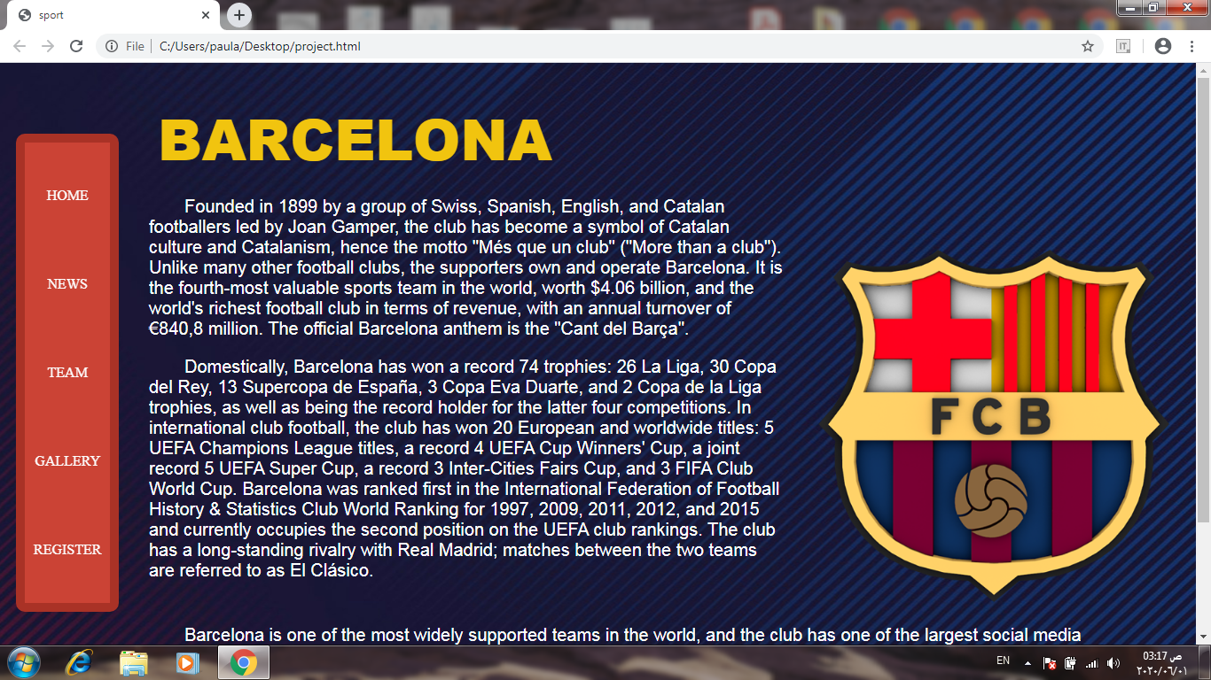**First page (Home)**

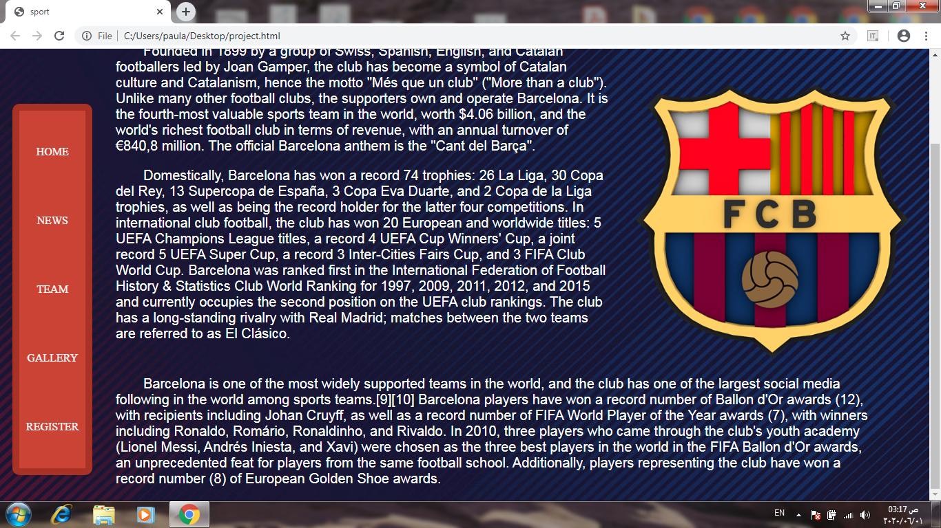

My website is about sport , especially about Barcelona football club.

In the first page I used a fixed Navigation Bar as shown by scrolling in the page.

And I used p tag for making these paragraphs. And img tag for the image.

That’s about HTML. I used CSS for styling the page by determining the position of

Every element such as: the image , the navigation bar and the header. And determining its color and font style , and the background image.

**Second page (News)**

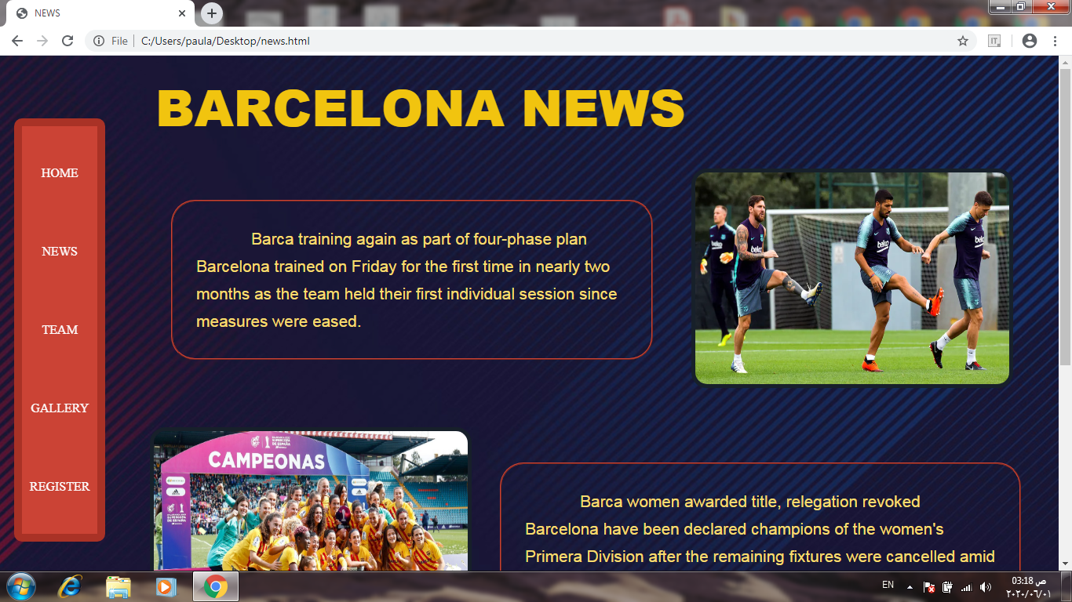

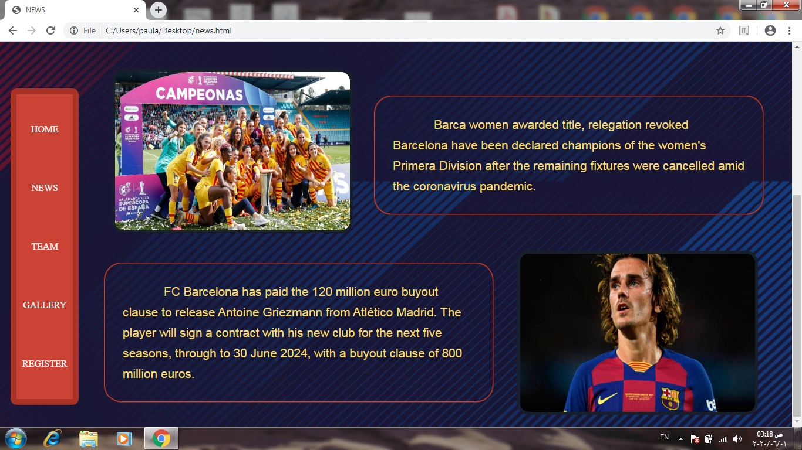

We see that to be at the same theme , I made the navigation bar and the background the same at all pages. In this page I put images next to its news by determining the position of each of them by CSS. And I put a border to each news and a border-radius for styling and the images too. Here I used the HTML in paragraphs and images.

**Third page (Team)**

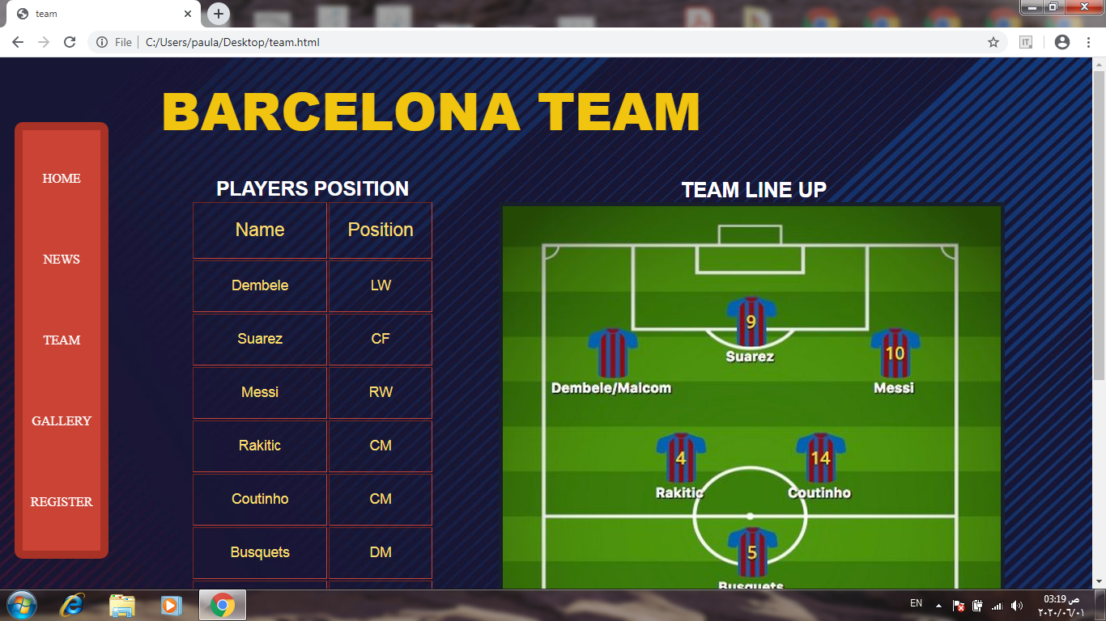

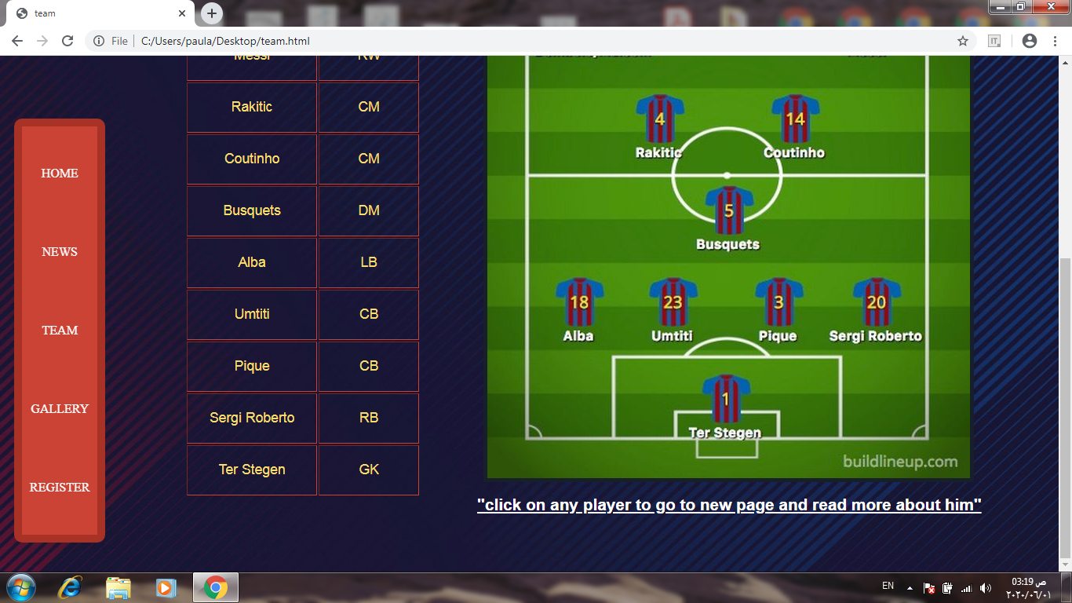

I made a table for the players position and a caption over it , put an image for the team line up and a paragraph under the image which leads to use the imagemap by clicking on the player to go to a new page about this player . I made it by HTML by determining the coordinates of the image and select the needed points. And the style of the table by CSS.

**Fourth page (Gallery)**

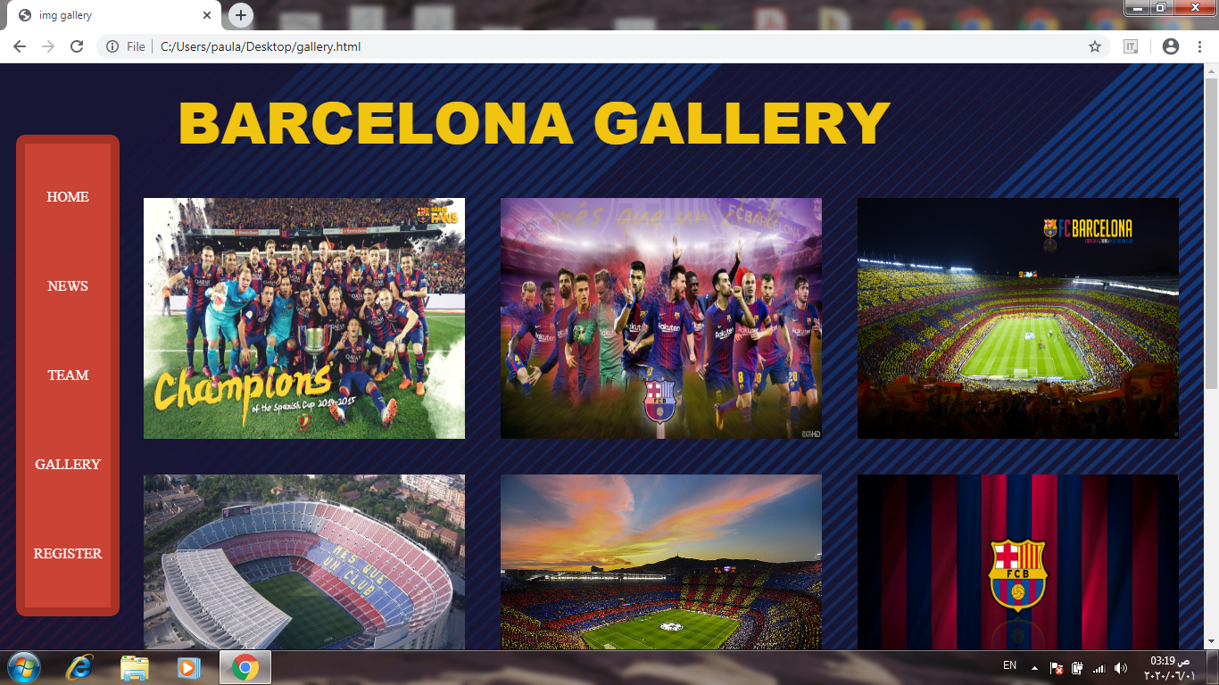

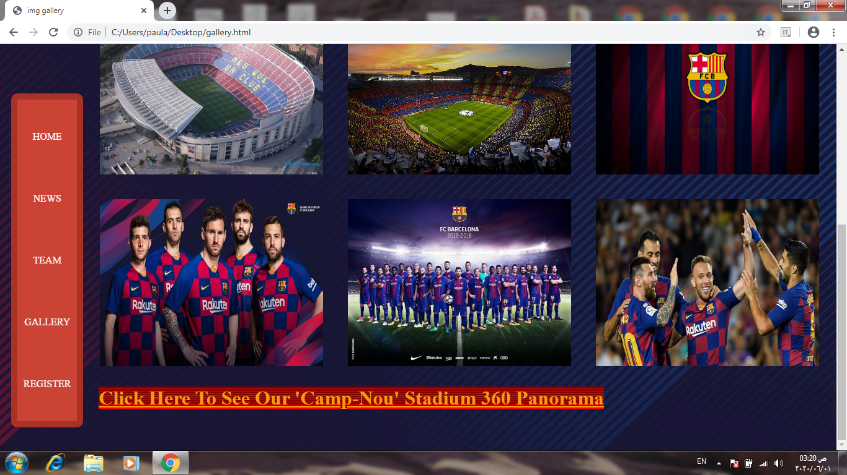

With the fixed navigation bar, an image gallery constructed with HTML by img tag, and designed by CSS.

And in the end of the page we find an URL (link) which leads us to a 360 panorama of The Camp-Nou stadium.

**Fifth page (Register)**

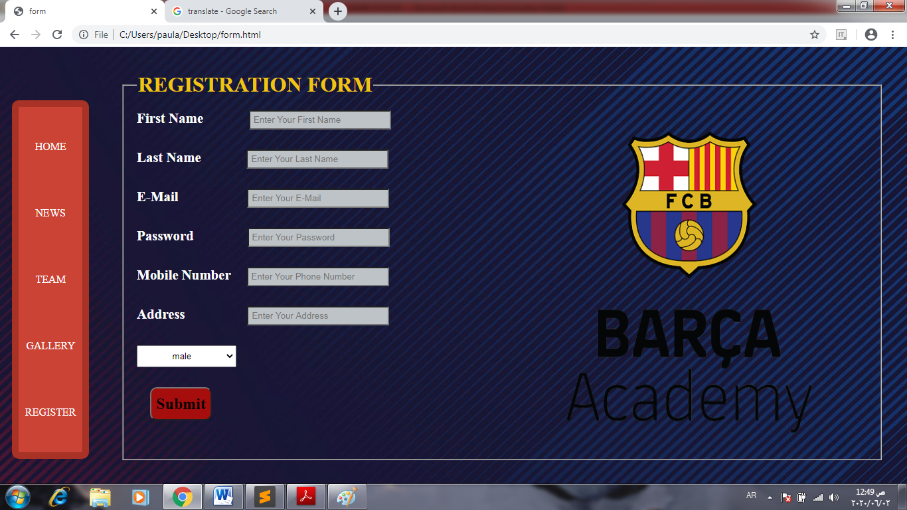

The last page is the Registration form that need some personal information and a logo image for the club with fieldset that made by HTML. The user must fill out the fields with the information, and we have terms to confirm the password which shown. And I test the validation of the e-mail address and the mobile phone number. I used Java Script in sending a message after press on Submit button

**Source Code:**

